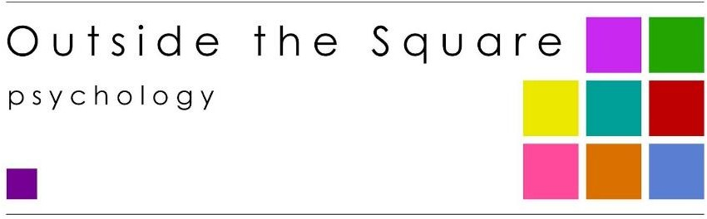

SERVICE | FEE | REBATE*
Autism Diagnostic Assessment: (82000: child)  (includes ADI-R/MIGDAS interview and ADOS-2/MIGDAS, consultation time with other professionals & written report, optional feedback session) | $2200  ($750, then $725 x 2 invoices) Plus your speech pathologist & paediatrician fee | Complex Neurodevelopmental Assessment items (CND)  ($101.52 per session for 4- 8 sessions)
Adult Autism Diagnostic Assessment | $2200 | May attract private health rebate
Autism and ADHD assessment (AuDHD) assessment | $2800 | Children: CND items  May attract private health rebate
Autism Diagnostic Observation Scale (ADOS-2) only 82000:  For reassessment/funding purposes | $1100  (includes report) | Complex Neurodevelopmental Treatment items $101.52
Adaptive Behaviour Assessment Vineland-3 teacher- OR parent-rating Form) | $650  (includes report) | Complex Neurodevelopmental Assess. items $101.52  May attract private health rebate
ADHD Screening Assessment  Intake session, Conners-4 ADHD scales OR Conners Comprehensive Behaviour Rating Scale OR BRIEF) | $650  (includes report) | Complex Neurodevelopmental Assess. items $101.52  May attract private health rebate
Formal Behaviour Assessment (Achenbach Child Behaviour Checklist; CBCL) | $650  (includes report) | Complex Neurodevelopmental Assess. items $101.52  May attract private health rebate
Cognitive assessment  (WPPSI-IV, WISC-V, WAIS-IV, WAIS-V)  Optional feedback session | $1200  (includes report) | Medicare rebate applies in limited circumstances (EPC, CND) $63.40/$101.50  May attract private health rebate
Academic Achievement Testing  (WIAT-III academic achievement)  Optional feedback session | $1200  (includes report) | Medicare rebate applies in limited circumstances (EPC, CND) $63.40/$101.52  May attract private health rebate
Specific Learning Difficulties Assessment  Minimum of Individual Achievement Test; WIAT AND Cognitive Assessment)  (some practitioners also choose to include C- TOPP assessment)  Optional feedback session | 2 x $1200 sessions  (includes report) | Medicare rebate applies in limited circumstances (EPC, CND) $63.40/$101.52 per session  May attract private health rebate

50–60-minute Standard Consultation  50+ mins Medicare, 60 mins NDIS  - counselling and therapy  - behaviour management  - skills building  - assessment feedback consultation | $230  $252.99 | ‘Better Access’ MHCP $101.52  ‘Complex Neurodevelopmental’ $101.52  ‘Enhanced Primary Care’  $63.40  NDIS psychologist rate 1/7/2026
Support Letter Writing  For funding or special consideration | $115  Minimum 30 mins (Or $230 per hour) | No Medicare rebate applies  May attract private health rebate
NDIS application completion or progress report for plan review | $252.99  Minimum 60 mins | NDIS psychologist rate 1/7/2026

*Higher level of rebate if you have reached the Medicare Safety Net Threshold

Cancellation Policy: 48 hours’ notice is required to cancel or reschedule an appointment; this gives us time to offer the booking to someone else. If less than 48 hours’ notice is given the full fee will be charged.

Fees current as of 1st July 2026

